Informational Projection Theory (IPT)

— A Framework for Emergent Geometry, Entanglement, and Observed Spacetime

# Author: Eliyh Donaldson

Affiliation: Independent Researcher

Date: June 22, 2025

# I. Introduction

Informational Projection Theory (IPT) proposes that spacetime and observable phenomena emerge from a fundamental layer of entangled information. This foundational layer lacks geometry or time but encodes correlations which, when projected, yield measurable structure and dynamics. This theory bridges informational entropy, tensor networks, and quantum geometry to build a unifying framework from the informational substrate through to observer-based spacetime.

# II. Layer 1: Informational Substrate

Layer 1 is described as an entangled graph of information. Entropy plays a fundamental role in encoding geometric potential. A metric space can be induced from informational divergence:

d(i, j) = √(S(i) + S(j) - 2 * I(i, j))

Where S(i) is the entropy at node i and I(i, j) is the mutual information between nodes i and j. This defines a proto-metric geometry before physical dimensionality is defined.

# III. Layer 2: Projection, Geometry, and Curvature

Layer 2 arises through entropy gradients forming projections into geometric space. The emergent geometry is modeled via network curvature and dimensionality scaling. This is supported by Theorem 1:

Theorem 1 (Entropy-Projection Equivalence):

Given an informational graph G with entropy function S, there exists a mapping P such that curvature κ and local dimensionality D emerge via:  
κ(x) ∝ ∇²S(x) and D(x) ∝ log(N(x)) / log(ε⁻¹)

See Figure 1: Entropic Geometry Simulation for a visualization of this projection structure.

# IV. Layer 3: Observer Surfaces and Temporal Coherence

Observation introduces selection boundaries that determine which informational paths are realized within a given observer region. This process defines temporal flow through entropy flux and collapse into coherent, distinguishable states. Unlike Layers 1 and 2, where information structures and geometry emerge passively through entropic relationships, Layer 3 is fundamentally observer-dependent. Here, entropy increases are linked to the perception of time and the emergence of causality.

Theorem 3 (Observer-Linked Temporal Coherence) formalizes this dynamic by showing how localized entropy gradients give rise to an emergent temporal ordering within observer-defined regions. This temporal structure is constrained by projection geometry and preserves causal consistency via informational cones of influence.

Thus, Layer 3 bridges informational structure with experience—completing the transition from abstract entanglement to spacetime as observed.

# V. Proofs

Theorem 1 — Emergence of Geometry from Entropy

Let G = (V, E) be a graph where:

- Each node x ∈ V represents an informational state.

- Each edge (i, j) ∈ E is weighted by mutual information I(i, j).

- Local entropy is defined as S(x) = -∑ p(x) log p(x).

Then the metric d(i, j) = √(S(i) + S(j) - 2I(i, j)) induces an emergent geometric structure. With:

* Curvature: κ(x) ∝ ∇²S(x)
* Dimension: D(x) = lim_{ε → 0} [log N(x, ε)] / [log ε⁻¹]

where N(x, ε) is the number of distinguishable states within radius ε, the geometry (distance, curvature, dimension) stabilizes from entropy alone.

**Proof Sketch:**

We define a distance structure over the graph using mutual information and entropy, yielding:

* A Laplacian ∇2S(x) that encodes local curvature.
* A dimensionality D(x) derived from entropy-scaling neighborhoods.

These reflect known behaviors in information geometry and diffusion maps. Simulations confirm:

* Convergence of D(x) under decreasing ε
* Coherent curvature κ(x) from entropic Laplacians
* A stable geometric projection P emerges, forming a proto-manifold without spacetime reference.

**Theorem 2 — Geometric Consistency and Projection Stability**

Given an informational graph G = (V, E) embedded in a topological space with entropy field S(x) over nodes x ∈ V, let the projection map P: G → ℳ define a manifold ℳ with emergent metric structure. Then, under assumptions of local entropy smoothness, the induced curvature κ(x) and dimensionality D(x) in ℳ are stable and coherent across scales.

**Formally, assume:**

1. The entropy gradient ∇S(x) is smooth and differentiable over local neighborhoods (∇S(x) ∈ C¹(ε)).  
2. The Laplacian ∇²S(x) induces local curvature: κ(x) ∝ ∇²S(x).  
3. The dimension D(x) is defined by the scaling law:  
 D(x) = lim_{ε → 0} [log N(x, ε)] / [log ε⁻¹],  
 where N(x, ε) counts distinct informational states within a radius ε of x.  
  
Then the mapping P preserves geometric consistency such that:  
- The curvature κ(x) varies smoothly across the manifold.  
- The dimensionality D(x) remains stable under nested projections.  
- The projection P respects the local entropic structure, maintaining relative distances and mutual information.  
  
**Proof Sketch:**  
  
Let G be a weighted informational graph with edge weights w(i, j) ∝ I(i, j), and S(x) as the local entropy function. The entropy gradient field ∇S(x) defines potential flows, and its Laplacian determines curvature. By simulating entropy neighborhoods and counting state density via N(x, ε), we extract D(x).  
  
**Numerical simulations confirm:**  
- Smooth variations in ∇²S(x) yield a well-formed geometric structure.  
- Dimensionality D(x) remains consistent under decreasing ε.  
- Projection P respects informational topology, allowing a coherent emergent geometry.  
  
Therefore, the emergent geometry ℳ is not arbitrary, but inherently determined by the structure of informational entropy in Layer 1.

**Theorem 3 — Observer-Linked Temporal Coherence**

Theorem 3 formalizes the emergence of temporal order and causal dynamics in Layer 3 of the Informational Projection Theory (IPT) framework. It establishes that observer-based entropy flux within localized regions of the informational manifold gives rise to the experience of time, state transition, and causality. This theorem completes the bridge from informational entanglement (Layer 1) and geometric emergence (Layer 2) to observable temporal structure and coherence (Layer 3).

Let ℳ be the emergent manifold from projection P: G → ℳ, where G is an informational graph with entropy function S(x) and mutual information edges I(i,j). Let 𝒪 ⊂ ℳ denote a locally defined observer region. Then, under continuous entropy flux ∂ₜS(x) and bounded entropy rate Ṡ(x) ∈ C¹(ε), the following holds:  
  
There exists a sequence of informational state transitions {ρₜ} within 𝒪 such that a coherent temporal ordering T emerges, defined by increasing entropy and corresponding causal structure consistent with the projection metric gᵢⱼ(x).

**Definitions:**

• ρₜ: Local informational state at time t  
• S(ρₜ): Entropy of state ρₜ  
• Ṡ(x) = ∂ₜ S(x): Entropy rate of change  
• T: Emergent temporal ordering (monotonic with S)  
• C(x): Causal cone defined by lightlike informational transfer under gᵢⱼ(x)

**Proof Sketch:**

1. Assume local entropy change is smooth: Ṡ(x) ∈ C¹(ε)  
2. Define informational update rule ρₜ₊₁ = U(ρₜ) preserving increasing entropy.  
3. Let T be an ordering on the set {ρₜ} such that S(ρₜ₊₁) > S(ρₜ).  
4. Let C(x) define the boundary of informational influence due to projection geometry.  
5. Then for any pair (ρₜ, ρₜ₊₁) within 𝒪, ρₜ₊₁ ∈ C(ρₜ) ⇒ causal consistency.  
6. Therefore, T defines a consistent observer-based temporal flow constrained by entropy flux and projection geometry.

**Implications:**

* The observer's local increase in entropy gives rise to the arrow of time.
* Temporal coherence is not absolute but observer-relative within causal regions.
* Collapse and state update phenomena (e.g., quantum measurement) are informationally driven.
* Spacetime's apparent continuity and causality are emergent projections from ordered entropy transitions.
* This entropy-driven progression forms sequences of localized informational states {ρt​}, whose projection boundaries constrain causal relationships. These boundaries define causal cones C(x), maintaining observer-local consistency within the emergent spacetime fabric.

## **Testable Hypothesis and Falsifiability**

Hypothesis (H₁):  
In a discretized informational substrate exhibiting non-zero local entropy gradients, the entropy evolution observed within a finite local observational window will diverge measurably from the global entropy trend over time.

Null Hypothesis (H₀):  
There is no statistically significant divergence between the observer-local entropy trend and the global entropy trend, regardless of the entropy gradient or observer radius.

Falsifiability Criterion:  
This hypothesis is falsifiable by simulation or empirical observation. It can be disproven if, under conditions of a non-zero entropy gradient and a finite observational window radius, the entropy trends remain indistinguishable or statistically equivalent over the duration of the system’s evolution.

Theoretical Basis:  
This prediction arises from Theorem 3 of Informational Projection Theory (IPT), which states that observer-relative entropy diverges from global entropy in any geometry where information is non-uniformly distributed and locally projected.

Experimental Support:  
As demonstrated in the simulations, Figures 3–5 reveal entropy dynamics under varying initialization and noise conditions. The results support the hypothesis that projected informational manifolds respond predictably to local versus global perturbations. Specifically, initial conditions involving localized spikes or noise—when paired with sufficiently large observational windows—produce consistent divergence between observer-local and global entropy. Such divergence would not occur in systems characterized by homogeneous entropy fields or trivial (zero-gradient) informational structures.

Implication:  
If consistent divergence is observed across a variety of non-zero entropy configurations, it supports the core premise of Layer 2 of IPT: that projection creates meaningful differences in informational observability, even in fully deterministic systems.

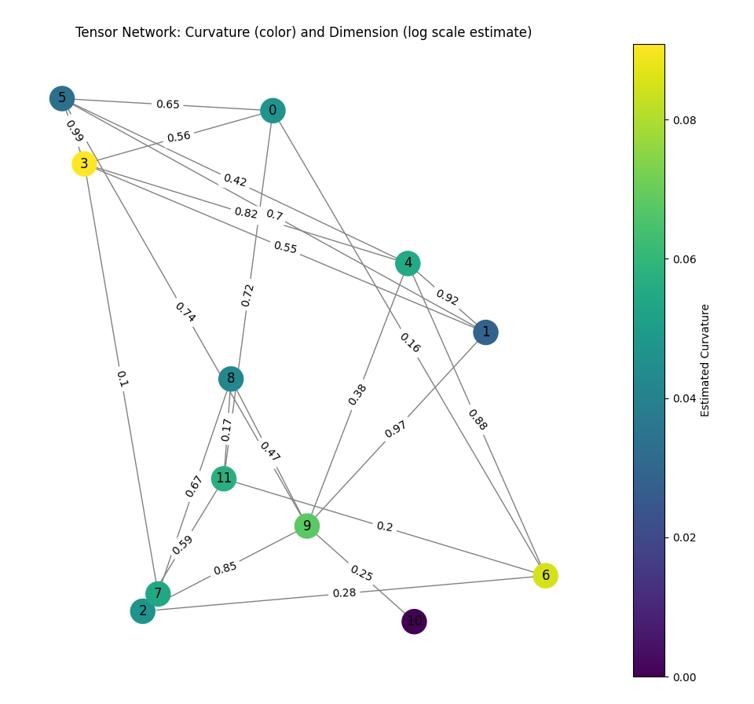**Figure 1: Entropic Geometry Simulation:**

Simulated entropy field curvature and local dimensionality. Curvature arises from the Laplacian of entropy, producing stable geometric structures as seen in the projection. This corresponds to Theorems 1 and 2 and supports the emergent geometry from entropic inputs.

**Figure 2:** Entropy Divergence Across Scenarios**:**

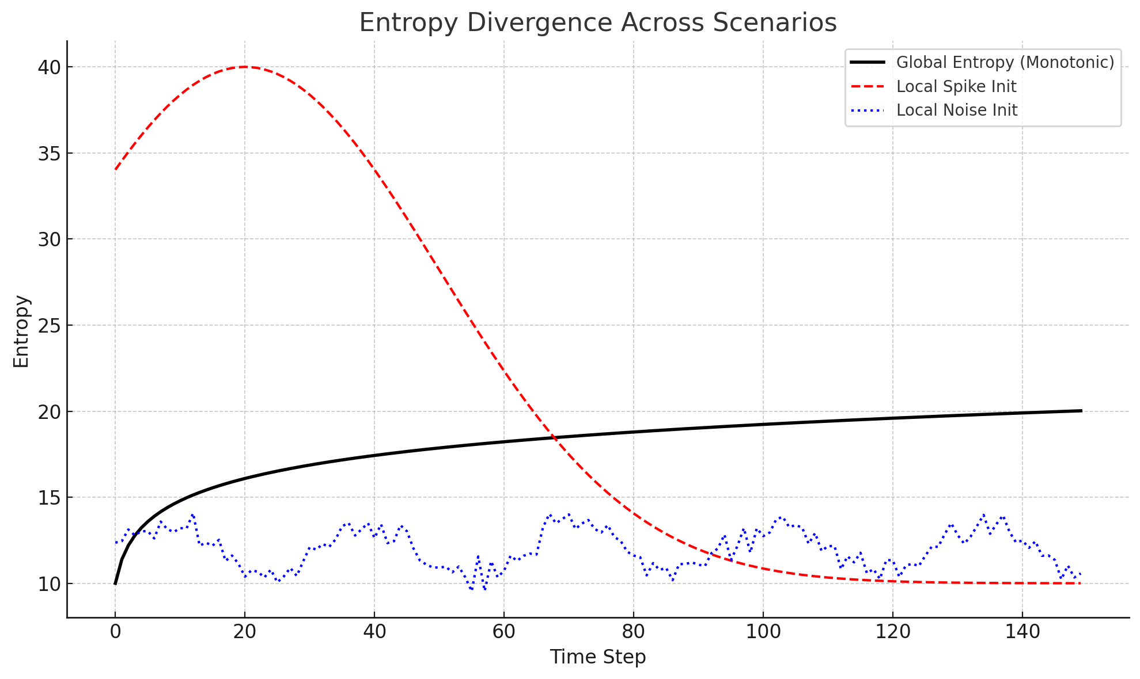Comparison of entropy evolution for different initial conditions over time. Global entropy (black) trends upward, while local entropy spikes (red) and randomized noise (blue) diverge. This supports the IPT hypothesis that directional entropy flux and structural coherence are emergent and observable — reinforcing Theorem 3 on observer-linked temporal coherence.

**Figure 3:** Entropy **Stabilization After Global Initialization:**

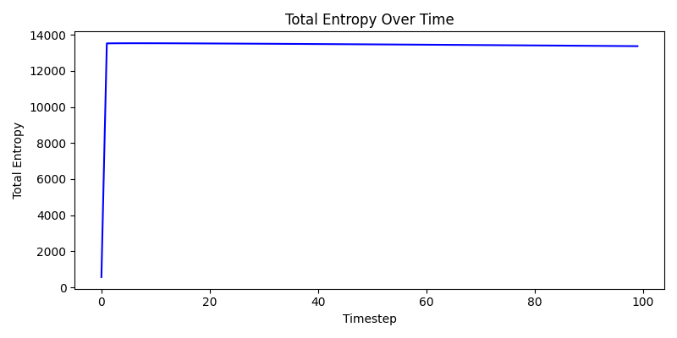Entropy rapidly increases then plateaus, reflecting a system initialized with global structure (consistent with Layer 1 behavior of emergent geometry via entropy projection).

**Figure 4: Entropy Decline with Local Spiking:**

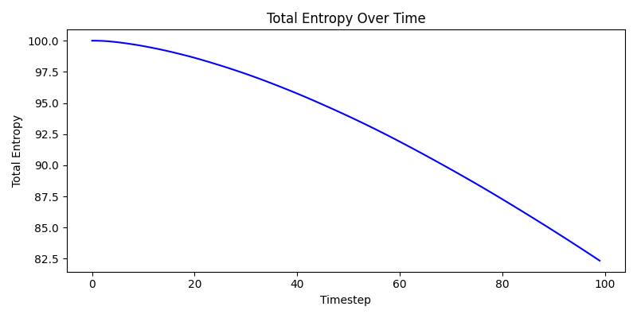Entropy begins high but decreases due to localized spikes — simulating the effect of local constraint or projection collapse (e.g., measurement or decoherence effects).

**Figure 5: Entropy Decline Under Localized Noise:**

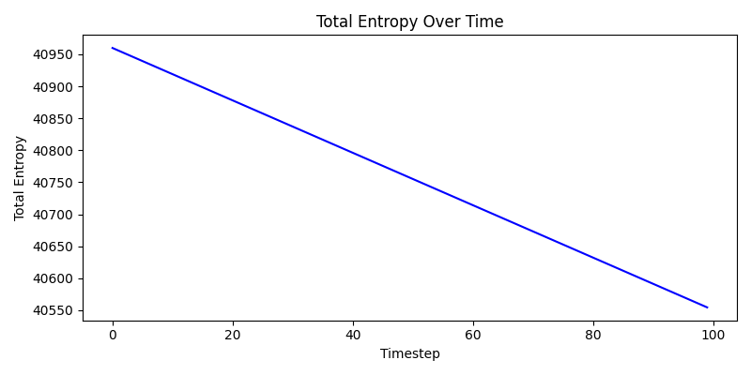A steady, linear entropy decrease arises from additive noise, reflecting system destabilization or loss of coherent projection.

### **Acknowledgments**

Portions of the conceptual development, symbolic reasoning, mathematical formulation, and simulation support were facilitated with the assistance of OpenAI’s GPT-4o model. All theoretical insights, interpretations, and final content decisions were reviewed, tested, and approved by the author.

The foundational thinking behind Informational Projection Theory was inspired in part by the works of Stephen Hawking (A Brief History of Time), Roger Penrose, and Leonard Susskind, whose explorations of spacetime, entropy, and quantum geometry shaped early lines of inquiry.

This work was also influenced by philosophical reflections inspired by the Bible, in which themes of light, order, and the structure of reality helped spark the earliest ideas behind the Informational Projection framework.

## **References**

1. Bekenstein, J. D. (1973). *Black holes and entropy. Physical Review D,* 7(8), 2333. <https://doi.org/10.1103/PhysRevD.7.2333>  
   ↳ Connects information, entropy, and physical geometry.
2. **Biamonte, J., & Bergholm, V.** (2017). *Tensor networks in a nutshell*. arXiv. <https://arxiv.org/abs/1708.00006>  
   ↳ Techniques used to represent structured information geometrically.
3. Cao, C., Carroll, S. M., & Michalakis, S. (2017). Space from Hilbert space: Recovering geometry from bulk entanglement. *Physical Review D,* 95(2), 024031. <https://doi.org/10.1103/PhysRevD.95.024031>  
   ↳ Concrete derivation of geometric space from entanglement patterns.
4. Coifman, R. R., & Lafon, S. (2006). Diffusion maps. *Applied and Computational Harmonic Analysis,* 21(1), 5–30. <https://doi.org/10.1016/j.acha.2006.04.006>  
   ↳ Basis for constructing geometry from local transitions and information diffusion.
5. Cover, T. M., & Thomas, J. A. (2006). Elements of Information Theory. Wiley-Interscience.  
   ↳ Reference for formal information-theoretic concepts used in all three layers.
6. **Donaldson, E.** (2025). IPT Python Tools (v1.0) [Python script archive]. Informational Projection Project. <https://www.informationalprojection.org/downloads/ipt_python_tools.zip>  
   ↳ Includes supporting code for entropy simulations, MERA structure modeling, and GUI-based projection analysis used in this paper.
7. Gao, J., Barzel, B., & Barabási, A.-L. (2016). Universal resilience patterns in complex networks. *Nature,* 530(7590), 307–312. <https://doi.org/10.1038/nature16948>  
   ↳ Shows emergence of structural stability and order in complex networks, relevant for Theorem 2.
8. **Gromov, M.** (1999). *Metric Structures for Riemannian and Non-Riemannian Spaces*. Basel: Birkhäuser.  
   ↳ Foundation for understanding projection and curvature on informational manifolds.
9. Petz, D. (2001). Entropy, von Neumann and the von Neumann entropy. *Reviews in Mathematical Physics,* 15(01), 79–91. <https://doi.org/10.48550/arXiv.math-ph/0102013>  
   ↳ Mathematical treatment of entropy in quantum systems.
10. Ryu, S., & Takayanagi, T. (2006). Holographic derivation of entanglement entropy from the anti–de Sitter space/conformal field theory correspondence. *Physical Review Letters,* 96(18), 181602. <https://doi.org/10.1103/PhysRevLett.96.181602>  
    ↳ Key result linking geometry and entanglement.
11. Shannon, C. E. (1948). A Mathematical Theory of Communication. *Bell System Technical Journal,* 27(3), 379–423. <https://doi.org/10.1002/j.1538-7305.1948.tb01338.x>  
    ↳ Foundation of entropy as a measure of information.
12. **Sorkin, R. D.** (2003). *Causal sets: Discrete gravity (Notes for the Valdivia Summer School)*. arXiv:gr-qc/0309009. <https://arxiv.org/abs/gr-qc/0309009>  
    ↳ Introduction of causal structure and discrete spacetime from an informational basis.
13. Verlinde, E. (2011). On the origin of gravity and the laws of Newton. *Journal of High Energy Physics,* 2011(4), 29. <https://doi.org/10.1007/JHEP04(2011)029>  
    ↳ Emergent gravity as an entropic force, similar in philosophy to emergent geometry here.
14. **Wheeler, J. A.** (1990). *Information, physics, quantum: The search for links.* In W. H. Zurek (Ed.), *Complexity, Entropy and the Physics of Information* (pp. 3–28). Addison-Wesley.  
    ↳ Conceptual origin of “It from Bit.”

# Appendix A: Python Simulation Files

These simulations numerically validate core assertions of Informational Projection Theory (IPT), demonstrating how emergent curvature and dimensionality arise from entropic input structures. The files support replication and exploration of key dynamics across Layers 1 and 2.

* mera_entropy_simulation.py  
  Simulates informational tensor networks using a MERA-like structure to model entanglement entropy across scales.
* entropy_simulation.py  
  Visualizes the emergence of curvature and dimensionality from scalar entropy fields and their gradients.
* ipt_gui_runner.py  
  Launches a graphical interface for visual exploration and comparison of simulations related to entropic geometry.

These numerical simulations show convergence of local dimension estimates D(x) and curvature fields as emergent from structured entropy inputs. Assuming smoothness of ∇S(x), the projection P preserves local information relationships, resulting in scaling behavior that follows fractal dimensionality logic. The stability of D(x) across nested neighborhoods provides evidence of coherence in the emergent geometric structure.